EXERCISE – 16 (PRINCIPAL COMPONENT ANALYSIS)
1. AIM
To apply Principal Component Analysis (PCA) to reduce the preprocessed heart disease feature space to two components and to measure the explained variance.
2. ALGORITHM
1. Load the dataset and separate the target.
2. Identify the numerical and categorical features.
3. Scale the numerical features and one-hot encode the categorical features.
4. Convert the processed data into a dense array when required.
5. Fit PCA with two components.
6. Transform the data and calculate the explained variance of each component.
7. Plot the two principal components.
3. PROGRAM
import pandas as pd
import matplotlib.pyplot as plt
from sklearn.compose import ColumnTransformer
from sklearn.preprocessing import StandardScaler, OneHotEncoder
from sklearn.decomposition import PCA
df = pd.read_csv("heart_disease_dataset.csv")
print("Dataset Shape:", df.shape)
print("\nFirst 5 records:")
print(df.head())
X = df.drop("Heart Disease", axis=1)
numeric_features = X.select_dtypes(
include=["int64", "float64"]
).columns
categorical_features = X.select_dtypes(
include=["object"]
).columns
preprocessor = ColumnTransformer(
transformers=[
("num", StandardScaler(), numeric_features),
("cat", OneHotEncoder(handle_unknown="ignore"), categorical_features)
]
)
X_processed = preprocessor.fit_transform(X)
# Check whether X_processed is sparse or already a NumPy array
if hasattr(X_processed, "toarray"):
X_processed = X_processed.toarray()
print("\nProcessed Data Shape:")
print(X_processed.shape)
pca = PCA(
n_components=2
)
X_pca = pca.fit_transform(X_processed)
pca_df = pd.DataFrame(
X_pca,
columns=[
"Principal Component 1",
"Principal Component 2"
]
)
print("\nPCA Transformed Data:")
print(pca_df.head())
print("\nExplained Variance Ratio:")
print(pca.explained_variance_ratio_)
total_variance = pca.explained_variance_ratio_.sum()
print("\nTotal Variance Explained:")
print(total_variance)
print(
"\nPercentage of Variance Explained:",
total_variance * 100,
"%"
)
plt.figure(figsize=(9, 6))
plt.scatter(
X_pca[:, 0],
X_pca[:, 1],
s=40
)
plt.xlabel("Principal Component 1")
plt.ylabel("Principal Component 2")
plt.title("PCA Visualization")
plt.grid(True)
plt.show()

4. OUTPUT
The program was executed on the Heart disease dataset (heart_disease_dataset.csv) and produced the following output:
Dataset Shape: (1000, 16)
First 5 records:
Age Gender ... Chest Pain Type Heart Disease
0 75 Female ... Atypical Angina 1
1 48 Male ... Typical Angina 0
2 53 Male ... Atypical Angina 1
3 69 Female ... Non-anginal Pain 0
4 62 Female ... Asymptomatic 0
[5 rows x 16 columns]
Processed Data Shape:
(1000, 27)
PCA Transformed Data:
Principal Component 1 Principal Component 2
0 0.014498 0.006885
1 1.327783 -1.536746
2 -0.344586 2.189857
3 -0.724487 0.102921
4 -2.001347 -0.278023
Explained Variance Ratio:
[0.09800253 0.09356834]
Total Variance Explained:
0.1915708662733832
Percentage of Variance Explained: 19.15708662733832 %
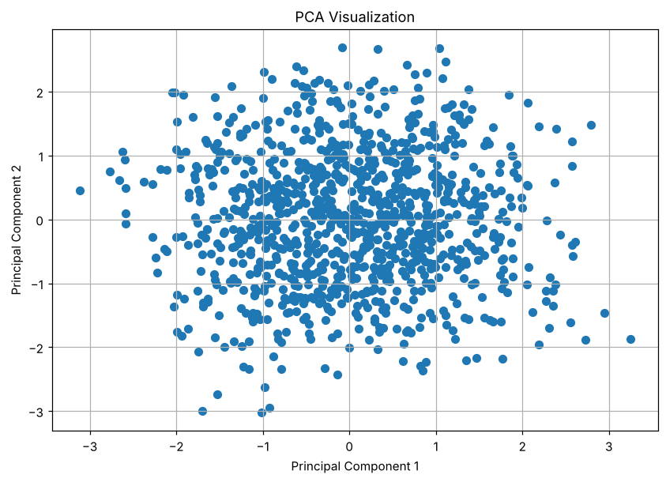

5. RESULT
Thus, the Principal Component Analysis practical was implemented successfully. The 27 processed features were reduced to two components that explain 9.80% and 9.36% of the variance, a total of 19.16%.

